Name _____________________________

2007 AP Statistics Multiple Choice Exam

Directions: Solve each of the following problems, using the available space for scratch work. Decide which is the best of the choices given and fill in the corresponding oval on the answer sheet. No credit will be given for anything written in the test book. Do not spend too much time on any one problem.

1. The statistics below provide a summary of the distribution of heights, in inches, for a simple random sample of 200 young children.

Mean: 46 inches
Median: 45 inches
Standard Deviation: 3 inches
First Quartile: 43 inches
Third Quartile: 48 inches

About 100 children in the sample have heights that are

(A) less than 43 inches
(B) less than 48 inches
(C) between 43 and 48 inches
(D) between 40 and 52 inches
(E) more than 46 inches

2. In which of the following situations would it be most difficult to use a census?

(A) To determine what proportion of licensed bicycles on a university campus have lights
(B) To determine what proportion of students in a high school support wearing uniforms
(C) To determine what proportion of registered students enrolled in a college are employed more than
20 hours each week
(D) To determine what proportion of single-family dwellings in a small town have two-car garages
(E) To determine what proportion of fish in Lake Michigan are bass

3. The distribution of the diameters of a particular variety of oranges is approximately normal with a standard deviation of 0.3 inch. How does the diameter of an orange at the 67th percentile compare with the mean diameter?

(A) 0.201 inch below the mean
(B) 0.132 inch below the mean
(C) 0.132 inch above the mean
(D) 0.201 inch above the mean
(E) 0.440 inch above the mean

4. Independent random samples of 100 luxury cars and 250 non-luxury cars in a certain city are examined to see if they have bumper stickers. Of the 250 non-luxury cars, 125 have bumper stickers and of the 100 luxury cars, 30 have bumper stickers. Which of the following is a 90 percent confidence interval for the difference in the proportion of non-luxury cars with bumper stickers and the proportion of luxury cars with bumper stickers from the population of cars represented by these samples?

(A) 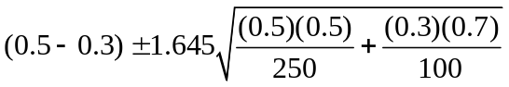
(B) 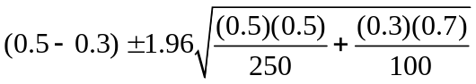
(C) 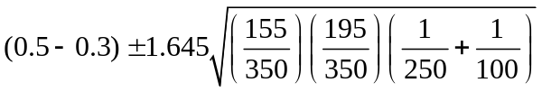
(D) 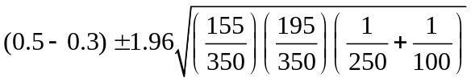
(E) 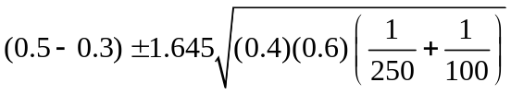

5. A safety group claims that the mean speed of drivers on a highway exceeds the posted speed limit of 65 miles per hour (mph). To investigate the safety group's claim, which of the following statements is appropriate?

(A) The null hypothesis is that the mean speed of drivers on this highway is less than 65 mph.
(B) The null hypothesis is that the mean speed of drivers on this highway is greater than 65 mph.
(C) The alternative hypothesis is that the mean speed of drivers on this highway is greater than 65 mph.
(D) The alternative hypothesis is that the mean speed of drivers on this highway is less than 65 mph.
(E) The alternative hypothesis is that the mean speed of drivers on this highway is greater than or equal
to 65 mph.

6. A fair coin is to be flipped 5 times. The first 4 flips land "heads" up. What is the probability of "heads" on the next (5th) flip of this coin?

(A)
(B) 
(C) 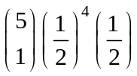
(D) 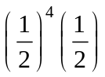
(E)
7. The stemplot below shows the yearly earnings per share of stock for two different companies over a sixteen-year period.

Company A Company B
0 58, 75, 96, 98
92, 91, 90, 82, 78, 43, 38, 26 1 01, 10, 17, 21, 43, 43, 53, 65, 73
49, 47, 44, 00 2 09, 27, 29
73, 27, 05, 02 3

Which of the following statements is true?
(A) The median of the earnings of Company A is less than the median of the earnings of the Company B.
(B) The range of the earnings of Company A is less than the range of the earnings of Company B.
(C) The third quartile of Company A is smaller than the third quartile of Company B.
(D) The mean of the earnings of Company A is greater than the mean of the earnings of Company B.
(E) The interquartile range of Company A is twice the interquartile range of Company B.

8. Let X represent a random variable whose distribution is normal, with a mean of 100 and a standard deviation of 10. Which of the following is equivalent to P(X > 115)?

(A) P(X < 115)
(B) P(X ≤ 115)
(C) P(X < 85)
(D) P(85 < X < 115)
(E) 1 − P(X < 85)

9. A television news editor would like to know how local registered voters would respond to the question, "Are you in favor of the school bond measure that will be voted on in an upcoming special election?" A television survey is conducted during a break in the evening news by listing two telephone numbers side by side on the screen, one for viewers to call if they approve of the bond measure, and the other to call if they disapprove. This survey method could produce biased results for a number of reasons. Which one of the following is the most obvious reason?

(A) It uses a stratified sample rather than a simple random sample.
(B) People who feel strongly about the issue are more likely to respond.
(C) Viewers should be told about the issues before the survey is conducted.
(D) Some registered voters who call might not vote in the election.
(E) The wording of the question is biased.

10. A high school physics teacher was conducting an experiment with his class on the length of time it will take a marble to roll down a sloped chute. The class ran repeated trials in order to determine the relationship between the length, in centimeters, of the sloped chute and the time, in seconds, for the marble to roll down the chute. A linear relationship was observed and the correlation coefficient was 0.964. After discussing their results, the teacher instructed the students to convert all of the length measurements to meters but leave the time in seconds. What effect will this have on the correlation of the two variables?

(A) Because the standard deviation of the lengths in meters will be one hundredth of the standard
deviation of the lengths in centimeters, the correlation will decrease by one hundredth to 0.954.
(B) Because the standard deviation of the lengths in meters will be one hundredth of the standard
deviation of the lengths in centimeters, the correlation will decrease proportionally to 0.00964.
(C) Because changing from centimeters to meters does not affect the value of the correlation, the
correlation will remain 0.964.
(D) Because only the length measurements have been changed, the correlation will decrease
substantially.
(E) Because meters are a much more common measurement for length in determining speed, the linear
relationship of the data will be stronger and thus the correlation will increase substantially.

11. Julie generates a sample of 20 random integers between 0 and 9 inclusive. She records the number of 6's in the sample. She repeats this process 99 more times, recording the number of 6's in each sample. What kind of distribution has she simulated?

(A) The sampling distribution of the sample proportion with n = 20 and p = 0.6
(B) The sampling distribution of the sample proportion with n = 100 and p = 0.1
(C) The binomial distribution with n = 20 and p = 0.1
(D) The binomial distribution with n = 100 and p = 0.1
(E) The binomial distribution with n = 20 and p = 0.6

 | n | Mean | Median
Sample I | 21 | 42.6 | 45.0
Sample II | 26 | 49.2 | 48.5

12. The table above shows the sample size, the mean, and the median for two samples of measurements. What is the median for the combined sample of 47 measurements?

(A) 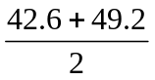
(B) 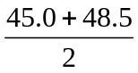
(C) 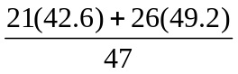
(D) 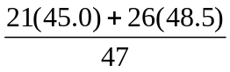
(E) It cannot be determined from the information given.
13. Dan, a trainer at the Popular Gym, was interested in comparing levels of physical fitness of students attending a nearby community college and those attending a 4-year college in town. He selected a random sample of 320 students from the community college. The mean and standard deviation of their fitness scores were 95 and 10, respectively. Dan also selected a random sample of 320 students from a 4-year college. The mean and standard deviation of their fitness scores were
92 and 13, respectively. He then conducted a two-sided t-test that resulted in a t-value of 3.27. Which of the following is an appropriate conclusion from this study?

(A) Because the sample means only differed by 3, the population means are not significantly different.
(B) Because the second group had a larger standard deviation, their mean fitness score is significantly
higher.
(C) Because the second group had a larger standard deviation, the mean fitness score of the first group
is significantly higher.
(D) Because the p-value is less than α = 0.05, the mean fitness scores for the two groups of students
are significantly different.
(E) Because the p-value is greater than α = 0.05, the mean fitness scores for the two groups of students
are significantly different.

14. A researcher wishes to test a new drug developed to treat hypertension (high blood pressure). A group of 40 hypertensive men and 60 hypertensive women is to be used. The experimenter randomly assigns 20 of the men and 30 of the women to the placebo and assigns the rest to the treatment. The major reason for separate assignment for men and women is that

(A) it is a large study with 100 subjects
(B) the new drug may affect men and women differently
(C) the new drug may affect hypertensive and nonhypertensive people differently
(D) this design uses matched pairs to detect the new-drug effect
(E) there must be an equal number of subjects in both the placebo group and the treatment group.

15. The histograms below represent the distribution of five different data sets, each containing 28 integers, from 1 through 7, inclusive. The horizontal and vertical scales are the same for all graphs. Which graph represents the data set with the largest standard deviation.
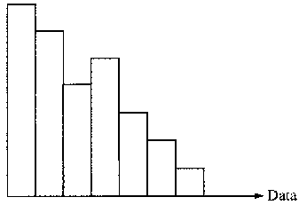
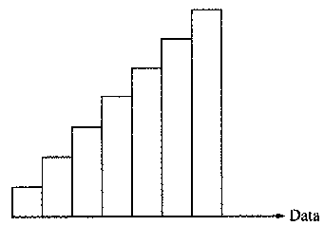
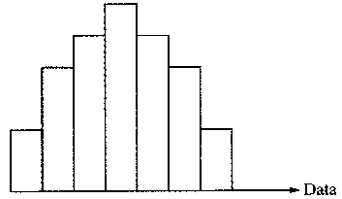
(A) (B) (C)

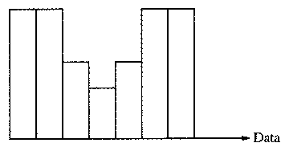
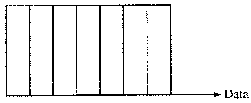
(D) (E)

16. Lynn is planning to fly from New York to Los Angeles and will take the Airtight Airlines flight that leaves at 8 A.M. The Web site she used to make her reservation states that the probability that the flight will arrive in Los Angeles on time is 0.70. Of the following, which is the most reasonable explanation for how that probability could have been estimated?

(A) By using an extended weather forecast for the date of her flight, which showed a 30% chance of
bad weather
(B) By making assumptions about how airplanes work, and factoring all of those assumptions into an
equation to arrive at the probability
(C) From the fact that, of all airline flights arriving in California, 70% arrive on time
(D) From the fact that, of all airline flights in the United States, 70% arrive on time
(E) From the fact that, on all previous days this particular flight had been scheduled, it had arrived on
time 70% of those days

17. In an experiment, two different species of flowers were crossbred. The resulting flowers from this crossbreeding experiment were classified, by color of flower and stigma, into one of four groups, as shown in the table below.
Flower Type Resulting from Crossbreeding | Number of Flowers Observed with These Colors
I: Magenta lower with green stigma | 115
II: Magenta flower with red stigma | 49
III: Red flower with green stigma | 32
IV: Red flower with red stigma | 21

A biologist expected that the ratio of 9:3:3:1 for the flower types I:II:III:IV, respectively, would result from this crossbreeding experiment. From the data above, a 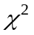 value of approximately 8.04 was computed. Are the observed results inconsistent with the expected ratio at the 5 percent level of significance?

(A) Yes, because the computed value is greater than the critical value.
(B) Yes, because the computed value is less than the critical value.
(C) No, because the computed value is less than the critical value.
(D) No, because the computed value is greater than the critical value.
(E) It cannot be determined because some of the expected counts are not large enough to use the
test.

18. One hundred people were interviewed and classified according to their attitude toward small cars and their personality type. The results are shown in the table below.
 |  | Personality Type
 |  | Type A | Type B | Total
Attitude | Positive | 25 | 12 | 37
Toward | Neutral | 11 | 9 | 20
Small Cars | Negative | 24 | 19 | 43
 | Total | 60 | 40 | 100

Which of the following is true?

(A) Of the three attitude groups, the group with the negative attitude has the highest proportion of
type A personality types.
(B) Of the three attitude groups, the group with the neutral attitude has the highest proportion of
type B personality types.
(C) For each personality type, more than half of the 100 respondents have a neutral attitude toward
small cars.
(D) The proportion that has a positive attitude toward small cars is higher among people with a type B
personality type than among people with a type A personality type.
(E) More than half of the 100 respondents have a type A personality type and a positive attitude toward
small cars.

19. A delivery service places packages into large containers before flying them across the country. These filled containers vary greatly in their weight. Suppose the delivery service's airplanes always transport two such containers on each flight. The two containers are chosen so their combined weight is close to, but does not exceed, a specified weight limit. A random sample of flights with these containers is taken, and the weight of each of the two containers on each selected flight is recorded. The weights of the two containers on the same flight

(A) will have a correlation of 0
(B) will have a negative correlation
(C) will have a positive correlation that is less than 1
(D) will have a correlation of 1
(E) cannot be determined from the information given

20. Which of the following is NOT a characteristic of stratified random sampling?

(A) Random sampling is part of the sampling procedure.
(B) The population is divided into groups of units that are similar on some characteristic.
(C) The strata are based on facts known before the sample is selected.
(D) Each individual unit in the population belongs to one and only one of the strata.
(E) Every possible subset of the population, of the desired sample size, has an equal chance of being
selected.
21. A city is interested in building a waste management facility in a certain area. One hundred randomly selected residents from this area were asked, Do you support the city's decision to build a waste management facility in your area?" Of the 100 residents interviewed, 54 said no, 4 said yes, and 42 had no opinion. A large sample z-confidence interval, 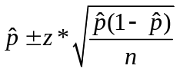, was constructed from these data to estimate the proportion of this area's residents who support building a waste management facility in their area. Which of the following statements is correct for this confidence interval?

(A) This confidence interval is valid because a sample size of more than 30 was used.
(B) This confidence interval is valid because each area resident was asked the same question.
(C) The confidence interval is valid because no conditions are required for constructing a large sample
confidence interval for a proportion.
(D) This confidence interval is not valid because the quantity 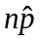 is too small.
(E) This confidence interval is not valid because "no opinion" was included as a response category for
the question.

22. The weights of a population of adult male gray whales are approximately normally distributed with a mean weight of 18,000 kilograms and a standard deviation of 4,000 kilograms. The weights of a population of adult male humpback whales are approximately normally distributed with a mean weight of 30,000 kilograms and a standard deviation of 6,000 kilograms. A certain adult male gray whale weighs 24,000 kilograms. This whale would have the same standardized weight (z-score) as an adult male humpback whale whose weight, in kilograms, is equal to which of the following?

(A) 21,000
(B) 24,000
(C) 30,000
(D) 36,000
(E) 39,000
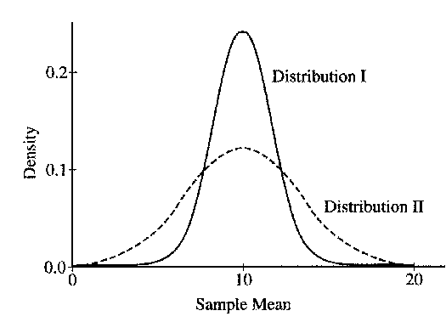

23. The graphs of the sampling distributions, I and II, of the sample mean of the same random variable for samples of two different sizes are shown below. Which of the following statements must be true about the sample sizes?

(A) The sample size of I is less than the sample size of II.
(B) The sample size of I is greater than the sample size of II.
(C) The sample size of I is equal to the sample size of II.
(D) The sample size does not affect the sampling distribution.
(E) The sample sizes cannot be compared based on these graphs.
24. The histogram below displays the times, in minutes, needed for each chimpanzee in a sample of 26 to complete a simple navigational task.
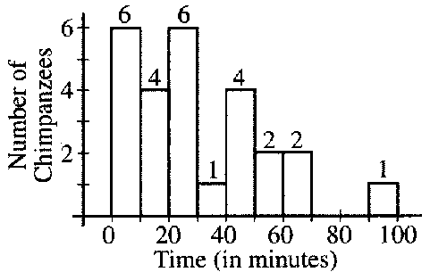

It was determined that the largest observation, 93, is an outlier since Q₃ + 1.5(Q₃ − Q₁) = 87.125. Which of the following boxplots could represent the information in the histogram?
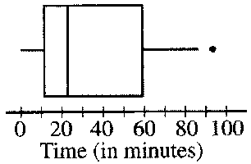
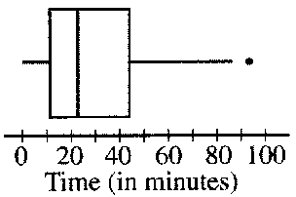
(A) (B)

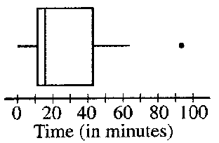
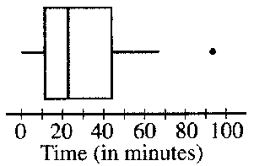
(C) (D)

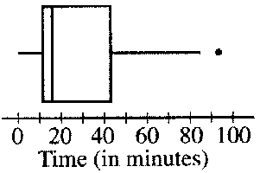
(E)

25. When performing a test of significance about a population mean, a t-distribution, instead of a normal distribution, is often utilized. Which of the following is the most appropriate explanation for this?

(A) The sample size is not large enough to assume that the population distribution is normal.
(B) The sample does not follow a normal distribution.
(C) There is an increase in the variability of the test statistic due to estimation of the population
standard deviation.
(D) The sample standard deviation is unknown.
(E) The population standard deviation is too large.

26. Random variable X is normally distributed with mean 10 and standard deviation 3, and random variable Y is normally distributed with mean 9 and standard deviation 4. If X and Y are independent, which of the following describes the distribution of Y − X?

(A) Normal with mean 1 and standard deviation −1
(B) Normal with mean −1 and standard deviation −1
(C) Normal with mean −1 and standard deviation 5
(D) Normal with mean 1 and standard deviation 7
(E) Normal with mean −1 and standard deviation 7

27. A t-statistic was used to conduct a test of the null hypothesis H₀: μ = 0 against the alternative
H_{a}: μ ≠ 0. The p-value was 0.056. A two-sided confidence interval for μ is to be constructed. Of the following, which is the largest level of confidence for which the confidence interval will NOT contain 0?

(A) 90% confidence
(B) 93% confidence
(C) 95% confidence
(D) 98% confidence
(E) 99% confidence

Student | 1 | 2 | 3 | 4 | 5 | 6 | 7 | 8 | 9 | 10
Height | 65 | 72 | 64 | 68 | 65 | 70 | 61 | 73 | 69 | 70
Arm Span | 67 | 71 | 60 | 69 | 60 | 65 | 58 | 74 | 70 | 67

28. The table above shows the height, in inches, and the arm span, in inches, for 10 randomly selected high school students. Which of the following significance tests should be used to determine whether a linear relationship exists between height and arm span, provided the assumptions of the test are met?

(A) Two-sample z-test
(B) Two-sample t-test
(C) Chi-square test of independence
(D) Chi-square goodness-of-fit test
(E) t-test for slope of regression line

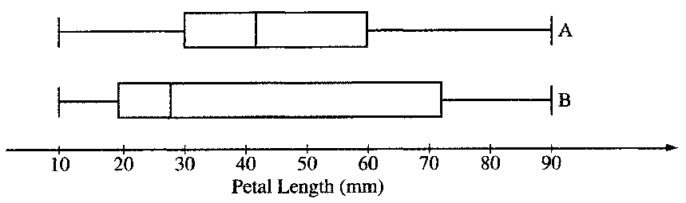

29. A botanist is studying the petal lengths, measured in millimeters, of two species of lilies. The boxplots above illustrate the distribution of petal lengths from two samples of equal size, one from species A and the other from species B. Based on these boxplots, which of the following is a correct conclusion about the data collected in this study?

(A) The interquartile ranges are the same for both samples.
(B) The range for species B is greater than the range for species A.
(C) There are more petal lengths that are greater than 70 mm for species A than there are for species B.
(D) There are more petal lengths that are greater than 40 mm for species B than there are for species A.
(E) There are more petal lengths that are less than 30 mm for species B than there are for species A.

30. A researcher has conducted a survey using a simple random sample of 50 registered voters to create a confidence interval to estimate the proportion of registered voters favoring the election of a certain candidate for mayor. Assume that a sample proportion does not change. Which of the following best describes the anticipated effect on the width of the confidence interval if the researcher were to survey a random sample of 200, rather than 50, registered voters?

(A) The width of the new interval would be about one-fourth the width of the original interval.
(B) The width of the new interval would be about one-half the width of the original interval.
(C) The width of the new interval would be about the same width as the original interval.
(D) The width of the new interval would be about twice the width of the original interval.
(E) The width of the new interval would be about four times the width of the original interval.

31. Automobile brake pads are either metallic or nonmetallic. An experiment is to be conducted to determine whether the stopping distance is the same for both types of brake pads. In previous studies, it was determined that car size (small, medium, large) is associated with stopping distance, but car type (sedan, wagon, coupe) is not associated with stopping distance. The experiment would be best done

(A) by blocking on car size
(B) by blocking on car type
(C) by blocking on stopping distance
(D) by blocking on brake pad type
(E) without blocking

32. An independent research firm conducted a study of 100 randomly selected children who were participating in a program advertised to improve mathematics skills. The results showed no statistically significant improvement in mathematics skills, using α = 0.05. The program sponsors complained that the study had insufficient statistical power. Assuming that the program is effective, which of the following would be an appropriate method for increasing power in this context.

(A) Use a two-sided test instead of a one-sided test.
(B) Use a one-sided test instead of a two-sided test.
(C) Use α = 0.01 instead of α = 0.05.
(D) Decrease the sample size to 50 children.
(E) Decrease the sample size to 200 children.

33. Five estimators for a parameter are being evaluated. The true value of the parameter is 0. Simulations of 100 random samples, each of size n, are drawn from the population. For each simulated sample, the five estimates are computed. The histograms below display the simulated sampling distributions for the five estimators. Which simulated sampling distribution is associated with the best estimator for this parameter?

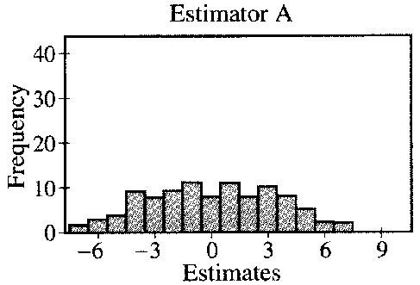
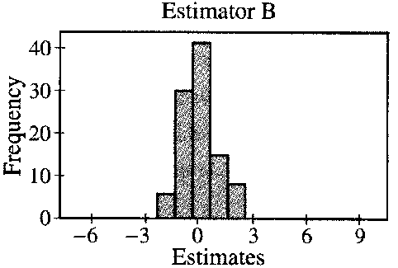
(A) (B)

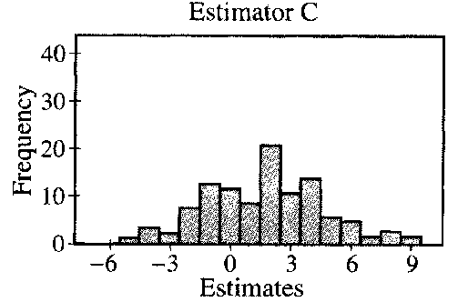
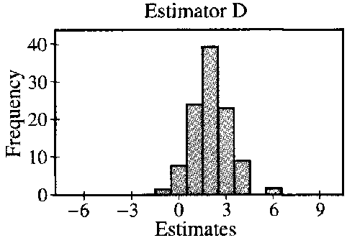
(C) (D)

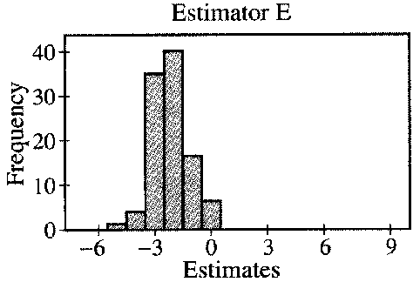
(E)
34. A planning board in Elm County is interested in estimating the proportion of its residents that are in favor of offering incentives to high-tech industries to build plants in that county. A random sample of Elm County residents was selected. All of the selected residents were asked, "Are you in favor of offering incentives to high-tech industries to build plants in your county?" A 95 percent confidence interval for the proportion of residents in favor of offering incentives was calculated to be 0.54 ± 0.05. Which of the following statements is correct?

(A) At the 95% confidence level, the estimate of 0.54 is within 0.05 of the true proportion of county
residents in favor of offering incentives to high-tech industries to build plants in the county.
(B) At the 95% confidence level, the majority of area residents are in favor of offering incentives to
high-tech industries to build plants in the county.
(C) In repeated sampling, 95% of sample proportions will fall in the interval (0.49, 0.59)
(D) In repeated sampling, the true proportion of county residents in favor of offering incentives to
high-tech industries to build plants in the county will fall in the interval (0.49, 0.59).
(E) In repeated sampling, 95% of the time the true proportion of county residents in favor of offering
incentives to high-tech industries to build plants in the county will be equal to 0.54.

35. A group of students has 60 houseflies in a large container and needs to assign 20 to each of the three groups labeled A, B, and C for an experiment. They can capture the flies one at a time when the flies enter a side chamber in the container that is baited with food. Which of the following methods will be most likely to result in three comparable groups of 20 houseflies each?

(A) Label the first 20 flies caught as Group A, the second 20 caught as group B, and the third 20 caught
as group C.
(B) Write the letters A, B, and C on separate slips of paper. Randomly pick one of the slips of paper
and assign the first 20 flies caught to that group. Pick another slip and assign the next 20 flies
caught to that group. Assign the remaining flies to the remaining group.
(C) When each fly is caught, roll a die. If the die shows an even number, the fly is labeled A. If the
die shows an odd number, the fly is labeled B. When 20 flies have been labeled A and 20 have
been labeled B, the remaining flies are then labeled C.
(D) Place each fly in its own numbered container (numbered from 1 to 60) in the order that it was
caught. Write the numbers from 1 to 60 on slips of paper, put the slips in a jar, and mix them
well. Pick 20 numbers out of the jar. Assign the flies in the containers with those numbers to
group A. Pick 20 more numbers and assign the flies in the containers with those numbers to
group B. Assign the remaining 20 flies to group C.
(E) When each fly is caught, roll a die. If the die shows a 1 or 2, the fly is labeled A. If the die shows
a 3 or 4, the fly is labeled B. If the die shows a 5 or 6, the fly is labeled C. Repeat this process
for all 60 flies.

36. An experiment has three mutually exclusive outcomes, A, B, and C. If P(A) = 0.12, P(B) = 0.61, and P(C) = 0.27, which of the following must be true?

I. A and C are independent.
II. P(A and B) = 0
III. P(B or C) = P(B) + P(C)

(A) I only
(B) I and II only
(C) I and III only
(D) II and III only
(E) I, II, and III

37. In a study of the weights of college athletes, player weights for a random sample of baseball players (BP) and for an independent random sample of hockey players (HP) were compared. The computer output shown below gives the result of a test of H₀: μ_{BP} = μ_{HP} versus H_{a}: μ_{BP} < μ_{HP}.

Two Sample T-Test and Confidence Interval

Two sample T for BP vs HP

N Mean StDev SE Mean
BP 37 197.8 19.4 3.2
HP 34 204.2 17.7 3.0

95% CI for μ BP − μ HP: (−15.1, 2.4)
T-Test μ BP = μ HP (vs <): T = −1.45 P = 0.076 DF = 69

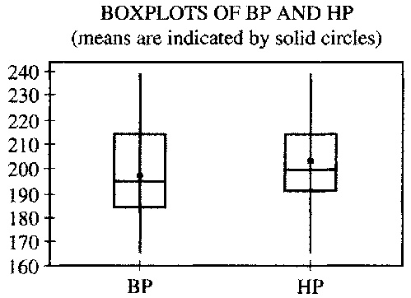

Which of the following is the best conclusion that can be drawn from the analysis?

(A) The mean weight of baseball players is not significantly lower than the mean weight of hockey
players at the 0.05 level.
(B) The mean weight of baseball players is not significantly lower than the mean weight of hockey
players at the 0.10 level.
(C) The mean weight of baseball players is significantly higher than the mean weight of hockey
players at the 0.10 level.
(D) The mean weight of baseball players is significantly lower than the mean weight of hockey
players at the 0.05 level.
(E) The mean weight of baseball players is significantly different from the mean weight of hockey
players at the 0.05 level.

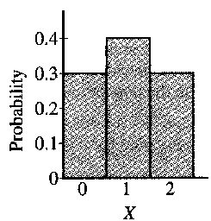

38. A game of chance is played in which X, the number of points scored in each game, has the distribution shown above. Which of the following is true for the sampling distribution of the sum, Y, of the scores when the game is played twice?

(A) Y takes on values 0, 1, 2 with respective probabilities 0.3, 0.4, and 0.3.
(B) Y takes on values 0, 2, 4 according to a binomial distribution with mean equal to 2.
(C) Y takes on values 0, 2, 4 with respective probabilities 0.3, 0.4, and 0.3.
(D) Y takes on values 0, 1, 2, 3, 4 according to a binomial distribution with mean equal to 2.
(E) Y takes on values 0, 1, 2, 3, 4 with respective probabilities 0.09, 0.24, 0.34, 0.24, and 0.09.

39. A polling organization asks a random sample of 1,000 registered voters which of two candidates they plan to vote for in an upcoming election. Candidate A is preferred by 400 respondents, Candidate B is preferred by 500 respondents, and 100 respondents are undecided. George uses a large sample confidence interval for two proportions to estimate the difference in the population proportions favoring the two candidates. This procedure is not appropriate because

(A) the two sample proportions were not computed from independent samples
(B) the sample size was too small
(C) the third category, undecided, makes the procedure invalid
(D) the sample proportions are different; therefore the variances are probably different as well
(E) George should have taken the difference 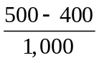 and then used a large sample confidence
interval for a single proportion instead

40. Two variables, x and y, were measured for a random sample of 25 subjects, and two separate regression models were fit to the data. Least squares estimation of the parameters in Model A yielded the following equation and residual plot.
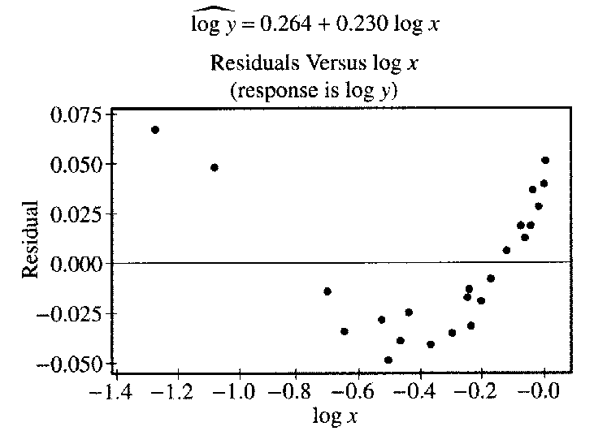

Least squares estimation of the parameters in Model B yielded the following equation and residual plot.
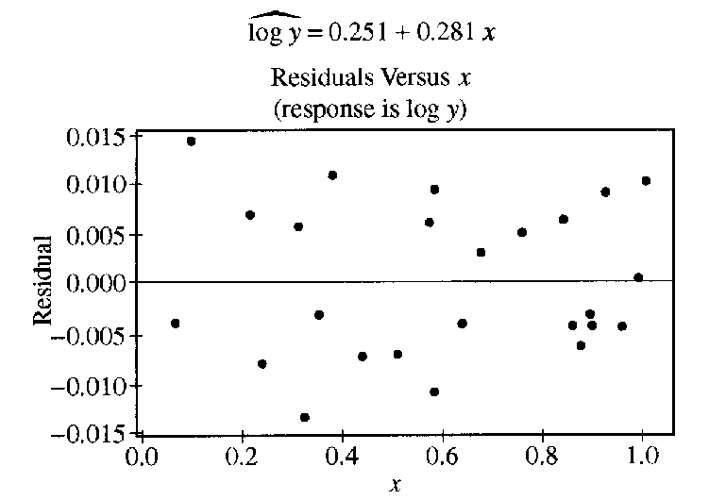

Which of the following conclusions is correct?

(A) Model A is appropriate, since the relationship between x and y is linear.
(B) Model B is appropriate, since the relationship between x and y is linear.
(C) Model A is appropriate, since the relationship between log x and log y is linear.
(D) Model A is appropriate, since the relationship between log x and y is linear.
(E) Model B is appropriate, since the relationship between x and log y is linear.

2007 MC Answer Key

1. C
2. E
3. C
4. A
5. C
6. B
7. D
8. C
9. B
10. C
11. C
12. E
13. D
14. B
15. D
16. E
17. A
18. B
19. B
20. E
21. D
22. E
23. B
24. D
25. C
26. C
27. B
28. E
29. E
30. B
31. A
32. E
33. B
34. A
35. D
36. D
37. A
38. E
39. A
40. E

